

Preliminary Project Scope Statement

Code Score Web Survey App v0.1 – Code Alliance

Date: Friday, 6 May 2016

Benetech Labs | Code Alliance

480 S. California Ave., Ste. 201

Palo Alto, California 94306-1609

Contents

1. Project Description 3

2. Project Purpose 3

3. Project Objectives 3

4. Project Requirements 3

5. Project Assumptions 3

6. Project Constraints 4

7. Project Boundaries 4

8. Project Risks 4

9. Project Deliverables 4

10. Project Milestones 5

11. Project High Level Work Breakdown Structure (WBS) 5

12. Rough Order of Magnitude (ROM) Estimate 5

13. Authorization 6

## Project Description

The project will implement a web application using open-source technology that will allow nonprofit groups construct surveys that can be sent to their volunteer coding and hackathon event participants, coinciding with the Chi4Good Day of Service on May 7, 2016 in San Jose, California, United States.

## Project Purpose

The purpose of the project is to help nonprofits test metrics across multiple hackathons and coding events and help provide data-driven insights into the value of engaging in volunteer events.

## Project Objectives

* The project will implement an open-source application which can allow nonprofit users to create customizable user surveys for their event participants.
* The developed application will conform to all tenets of the Open Source Definition, as defined by the Open Source Initiative, a non-profit organization based in San Francisco, California, United States dedicated to promoting and advocating the usage of open-source software.

## Project Requirements

Functional (user) requirements:

* The nonprofit user can enter survey questions of any format and style into the app (such as open-ended, qualitative, quantitative, etc.)
* The nonprofit user can group related questions into sets of questions
* The nonprofit user can assign absolute percentage weight values to the question sets (out of a total of 100%)
* The nonprofit user can assign relative percentage weight values to each individual question within each active question set (out of a total of 100%)
* The nonprofit user can assign negative values to either the absolute or relative percentage weights
* The nonprofit user can make adjustments to the questions, the number of active question sets, the absolute percentage weight values, and/or the relative percentage weight values in real-time

Non-functional (technical) requirements:

* The app must feature a user-friendly and user-intuitive design
* The app must be secured against server-side scripting and injection attacks

## Project Assumptions

Functional assumptions:

* When creating a survey, the nonprofit user will need no more than 8 active question sets.
* No major configuration is necessary on the part of the nonprofit user, other than adding and removing questions or changing the questions’ percentage weights

Non-functional assumptions:

* This is a desktop-based application
* The app is portable across multiple platforms
* The app requires an active PHP and *SQL* server-database configuration
* The app uses AngularJS, HTML, and CSS

## Project Constraints

* Timeline for development is approximately eight hours, coinciding with the Chi4Good Day of Service event on Saturday, 4 May 2016 in San Jose, California, United States
* Some team members will be joining the activities via Skype (and possibly across multiple time zones), so their participation is contingent upon time differences and working Internet connections.
* Author tested app beforehand, without web server, app only runs in Firefox; when running web server, app ran just fine
* Backbone.JS and other lightweight client-side database framework deemed unsuitable

## Project Boundaries

* The app will integrate a PHP/MySQL database server system.
* The app can currently be deployed on single systems (i.e. not recreating Survey Monkey) in its first version.

Example architecture diagram:



## Project Risks

Due to the user-interactive nature of the application (along with database integration incorporated into the system design), there is a risk of vulnerabilities to cross-site scripting-based and/or injection-based attacks. If/when user authentication/logging/token authorization is implemented in future iterations of the project and/or if/when the application is implemented over a distributed system, personal data would be at risk from such attacks if the system is not hardened against these threat vectors.

To mitigate the associated risks, the development team will adhere to good coding principles when implementing the application. Server-side validation is important to securing the application against attacks. Regular monitoring and code review will also aid in the risk deterrence. Fuzzing, when possible, should help to assess other vulnerabilities, and is highly recommended during the entire lifetime of this project.

## Project Deliverables

Project deliverables:

* A working customizable open-source web form survey app for deployment on desktop systems
* Associated documentation

## Project Milestones

|  |  |  |
| --- | --- | --- |
| Milestone Date | Milestone Name | Milestone Description |
| [23 -24 April, 2016] | Preliminary Scoping of Requirements | Initial examination of project requirements. |
| [1 - 5 May, 2016] | Pre-Development | Implementation of baseline version of app |
| [6 May, 2016] | Scope Requirements Complete | Scope document is complete, all project requirements documented |
| [7 May, 2016] | Day of Service Development | First official implementation of app during Chi4Good Day of Service |
| [8 May, 2016] | Chi4Good Plenary | Work on project highlighted during opening plenary at Chi4Good conference |
| [9 May, 2016] | Ongoing Development | Ongoing development of app |
|  |  |  |

## Project High Level Work Breakdown Structure (WBS)

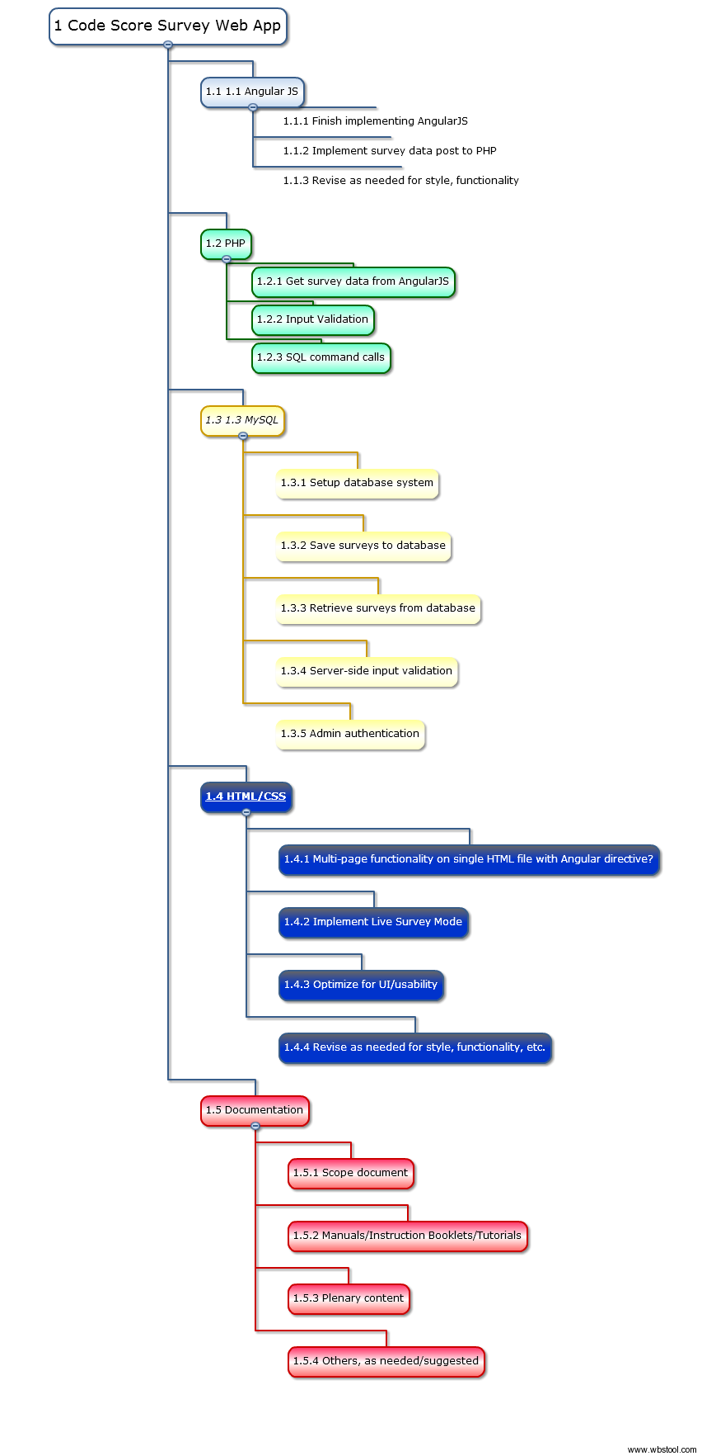



## Rough Order of Magnitude (ROM) Estimate

|  |  |
| --- | --- |
| Activity | Estimated Time |
| Preliminary Scoping of Requirements | 8-10 Resource Hours |
| Pre-Development | 15-20 Resource Hours |
| Scope Requirements Complete | 4-5 Resource Hours |
| Day of Service Development | 8 Resource Hours |
| Chi4Good Plenary | 1 Resource Hour |
| Ongoing Development | Ongoing |
|  |  |

## Authorization

Approved by the Project Sponsor:

Date:

[Project Sponsor]

[Project Sponsor Title], [Project Sponsor Organization or Division]